MERN STACK APP – Ticket App

Your app had problems on both the frontend and backend, and they combined into the behavior you were seeing:
- The ticket list API call failed on page load.
TicketList.js was calling GET http://localhost:5000/api/tickets as soon as the page loaded. But the backend only had a POST /api/tickets route, so the GET request failed every time and triggered the alert box.
- The backend did not support list, update, or delete operations.
In ticketroutes.js, only ticket creation existed. But the frontend expected all of these endpoints:
  - GET /api/tickets
  - POST /api/tickets
  - PUT /api/tickets/:id
  - DELETE /api/tickets/:id
- The Mongo schema did not match the frontend data.
In Ticket.js, the model only had:
  - title
  - description
  - status
  - createdAt
But the frontend was also using:
  - priority
  - createdBy
So even when tickets were created, some fields were missing or inconsistent.
- The form used inconsistent field names.
In TicketForm.js, the state mixed:
  - createdby
  - createdBy
Since JavaScript object keys are case-sensitive, this caused the submitted payload and reset behavior to be inconsistent.
- The list component used id instead of MongoDB _id.
Mongo documents come back with _id, but TicketList.js was using ticket.id for:
  - React key
  - delete
  - update
  - comparisons
Because of that, update/delete logic would not work properly.
- Status values were inconsistent.
The list logic checked both In progress and In Progress in different places. That mismatch could break status styling and behavior.
- The status badge class string was malformed.
The CSS class string in TicketList.js missed a space between class names, so the status badge styling would not apply correctly.
- The frontend package setup was invalid.
In package.json, react-scripts was set to ^0.0.0, which is not a usable CRA runtime. That is why build/start behavior was broken.
- Frontend dependencies were missing or incomplete.
node_modules/.bin was missing, so tools like react-scripts were not actually available to run.
- The default React test was outdated.
App.test.js still expected the default “learn react” text, which no longer existed in your app.
- The frontend hardcoded the backend URL.
The frontend directly used http://localhost:5000/api/tickets. That works sometimes, but using a CRA proxy plus relative /api/tickets is cleaner and avoids cross-origin issues during development.
- The frontend dev server had a Windows temp-directory startup issue.
react-scripts start was failing because of an EPERM error while trying to access a Windows temp path like C:\Users\ABHISH~1.
- The first npm start workaround still behaved inconsistently.
The initial start script used cmd-style environment variable setup. In your shell environment, it printed and exited instead of keeping the dev server attached.
Server Issue
The main server-side problem was that the backend was incomplete for what the frontend expected.
Before fixing it:
- the backend only supported creating tickets
- the frontend tried to fetch all tickets immediately on page load
- that caused the alert box
- update and delete buttons also had no real backend support
I fixed that by adding these routes in ticketroutes.js:
- GET /api/tickets
- PUT /api/tickets/:id
- DELETE /api/tickets/:id
I also confirmed server.js was already correctly mounting:
- app.use('/api/tickets', ticketRoutes)
and verified the backend responded successfully.
What I Changed
I updated the backend model in Ticket.js:
- removed stray incorrect code
- fixed required usage
- added priority
- added createdBy
- added valid enums for priority and status
I updated backend routes in ticketroutes.js:
- added list-all tickets
- added update ticket
- added delete ticket
- kept create ticket
I updated the frontend form in TicketForm.js:
- fixed createdBy naming
- fixed form reset values
- fixed console.log(error) handling
- changed labels from for to htmlFor
- cleaned a spacing warning
- changed API calls to /api/tickets
I updated the list component in TicketList.js:
- changed API calls to /api/tickets
- switched from id to _id
- fixed status comparison to In Progress
- fixed createdBy display
- fixed CSS class string for status badge
I updated frontend setup in package.json:
- set react-scripts to 5.0.1
- normalized React dependencies
- added "proxy": "http://localhost:5000"
- fixed the start script so it sets a local temp folder and runs correctly on your machine
I updated the test in App.test.js:
- removed the old CRA placeholder expectation
- replaced it with a real app check
How I Diagnosed It
I traced the issue in this order:
- Searched the codebase for TicketList, TicketForm, api/tickets, alert, and axios calls.
- Opened the frontend components to see where the alert was coming from.
- Checked the backend routes and found only POST existed.
- Checked the Mongoose model and saw it was missing fields used by the frontend.
- Fixed backend/frontend data mismatches.
- Verified the backend modules loaded successfully.
- Tried to build the frontend and found react-scripts was misconfigured.
- Repaired package.json and reinstalled dependencies.
- Built and tested the frontend successfully.
- Reproduced the dev-server startup issue and found the Windows temp-path permission error.
- Added a local .tmp workaround and made it permanent in the start script.
- Verified that npm start, npm run build, and the backend endpoint were working.
Why It Works Now
Now the app works because:
- the backend supports the same operations the frontend expects
- the schema matches the form/list fields
- the frontend uses Mongo _id correctly
- the frontend and backend communicate through the CRA proxy
- the React toolchain is installed and valid
- the frontend start command works reliably in your Windows environment

ANDROID Studio – Simple Calculator

AGP Version Incompatibility
The project is using an incompatible version (AGP 9.1.0-alpha09). Latest supported version is AGP 8.8.2
Root Cause: Your project was created using:
Android Gradle Plugin (AGP) 9.1 alpha
But you installed version of Android Studio that only supports AGP 8.8.2.
GP 9.x is a preview/canary version and not supported in stable Android Studio.
Fix Applied:
Located AGP version in gradle/libs.versions.toml
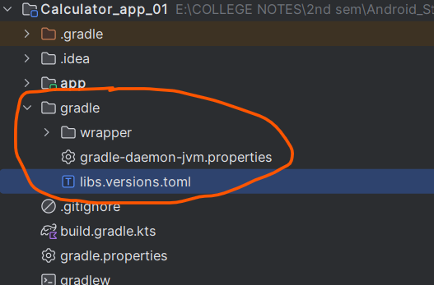

Changed agp = "9.1.0-alpha09" to agp = "8.8.2"
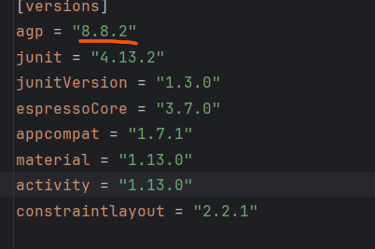

Gradle Version Mismatch
Minimum supported Gradle version is 8.10.2. Current version is 8.10
AGP 8.8.2 requires:
- Gradle 8.10.2 or higher

But project was using:
- Gradle 8.10

Fix Applied:
Opened gradle/wrapper/gradle-wrapper.properties
Changed to:
distributionUrl=https\://services.gradle.org/distributions/gradle-8.10.2-bin.zip
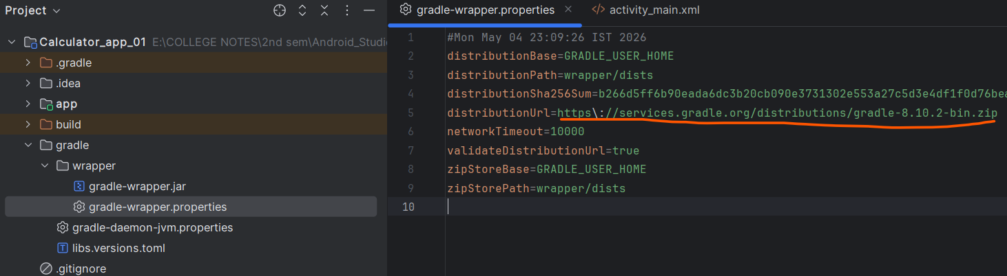

Kotlin DSL / AGP Syntax Error
Unresolved reference

